**Module 3: Docker Part 1**

**Assignment – 3**

**Tasks To Be Performed:**

1. Use the saved image in the previous assignment

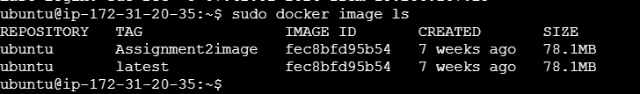

1. Upload this image on Docker Hub

Create dockerhub account and create repository

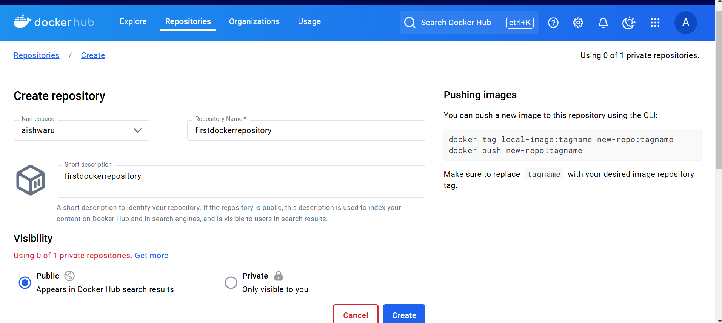

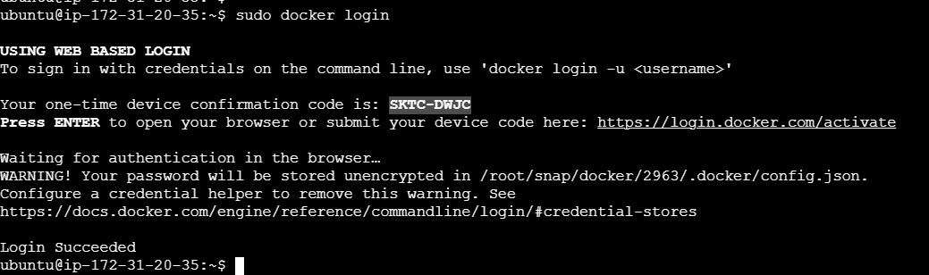

Go to the path and enter the code

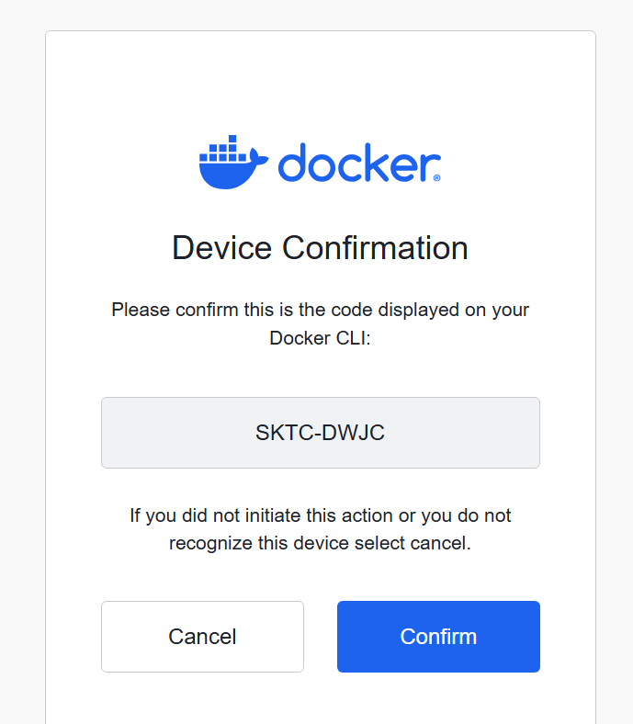

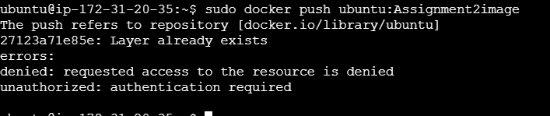

Because it is pointing to the docker.io and library repository so tag the image with our username/repository

And then try to push that tagged image it will succeed

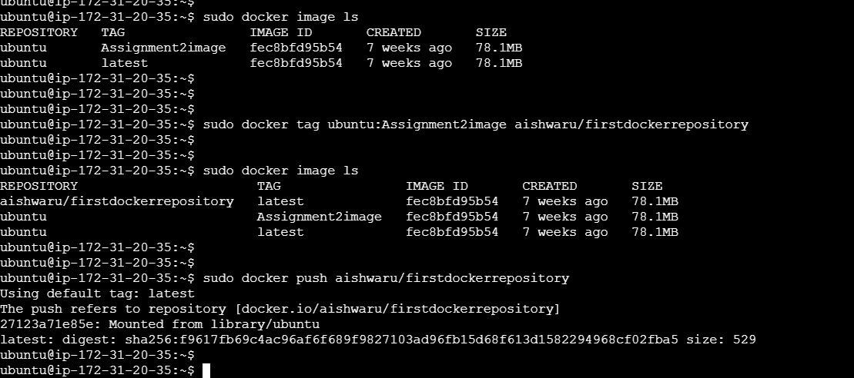

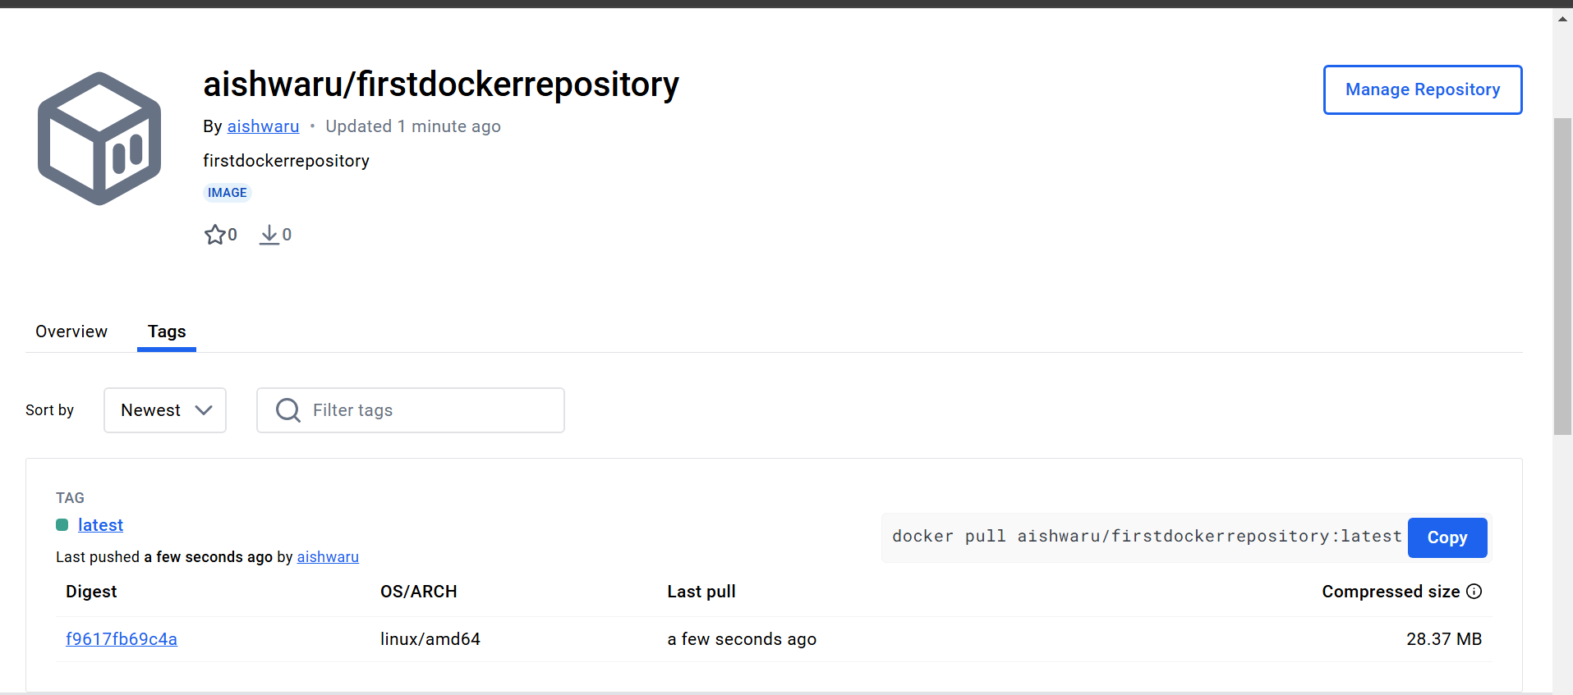

3. On a separate machine pull this Docker Hub image and launch it on port

80

Pull the image from dockerhub

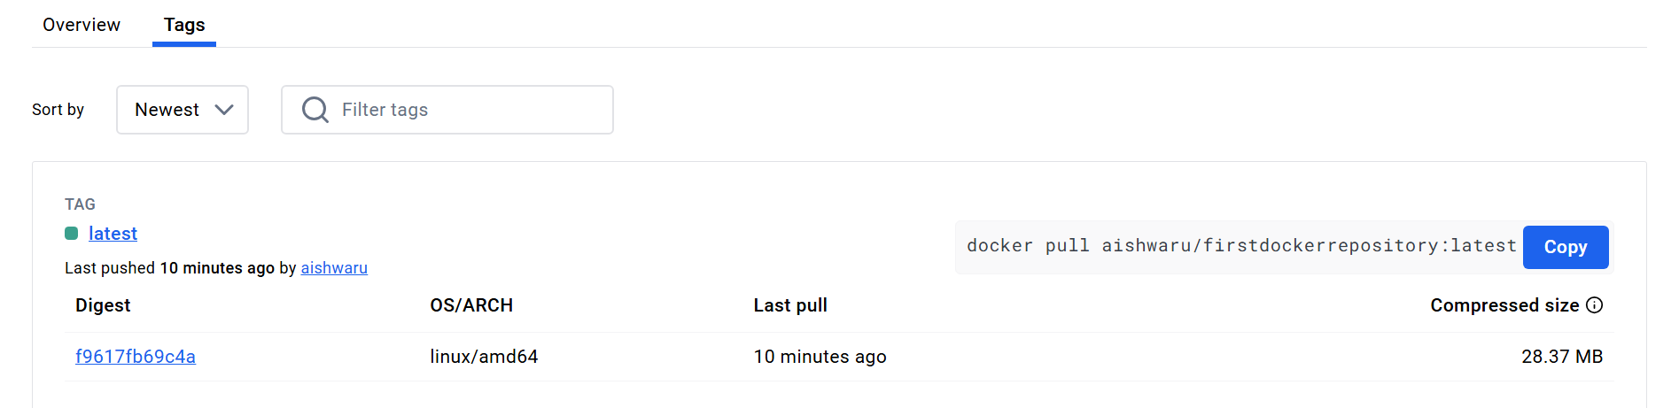

Pull the image

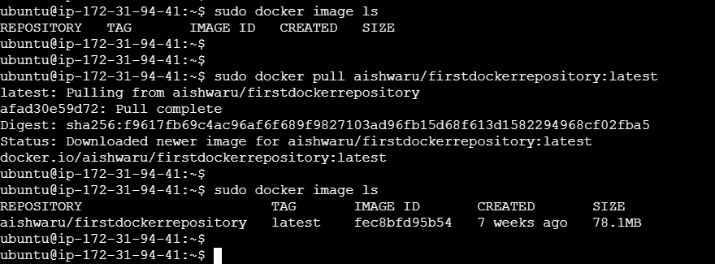

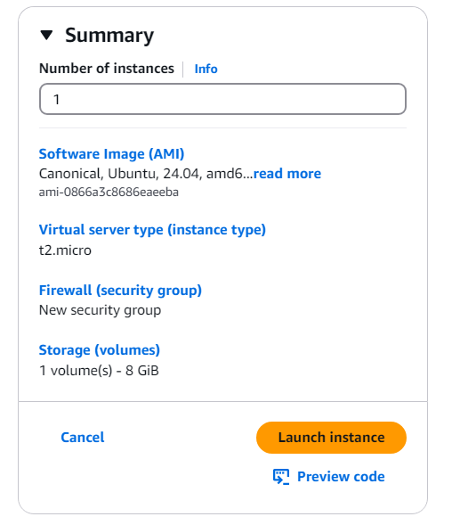

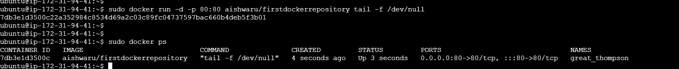

1. Start the Apache2 service



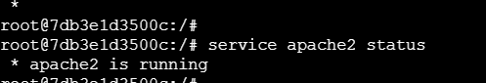

1. Verify if you are able to see the Apache2 service

